I was having trouble loading my final figure and R Markdown in RStudio. This is the code I had written. A copy of the complete code is found at the bottom of this document.

----

title: "Assignment 1"

author: "Giulietta Schutte"

date: "2025-09-19"

output:

pdf_document

This dataset was used to analyze deer movements to track the impacts (if any) of human and cougar presence on deer behavior. Locations were obtained from female mule deer fitted with a GPS-collar. This does skew the data towards female mule deer behavior and does not give a representation of the species as a whole since only one gender was studied.

I chose this data set because animal habitat use interests me. This data was made public on Dryad. Link to data: [Dryad | Data: Dynamic riskscapes for prey: Disentangling the impact of human and cougar presence on deer behavior using GPS smartphone locations](https://datadryad.org/dataset/doi:10.5061/dryad.51c59zwkg) . Link to published paper using this data: [Ecography - Wiley Online Library](https://nsojournals.onlinelibrary.wiley.com/doi/10.1002/ecog.07626)

The class of the dataset is dataframe.

Read in dataset:

'''readRDS("C:/Users/schut/Downloads/MD_dataset.RDS")

deermov=readRDS("C:/Users/schut/Downloads/MD_dataset.RDS")

View(deermov)

Variables of interest:

str(deermov) #variable (left) with its class type (right)

Classes ‘data.table’ and 'data.frame': 1854448 obs. of 23 variables:

$ burst_ : num 15 15 15 15 15 15 15 15 15 15 ...

$ sl_ : num 30.95 136.08 3.56 1.08 80.9 ...

$ ta_ : num 0.216 -2.635 3.087 -2.286 -1.592 ...

$ t1_ : POSIXct, format: "2019-05-31 22:00:00" "2019-05-31 22:00:00" "2019-05-31 22:00:00" "2019-05-31 22:00:00" ...

$ t2_ : POSIXct, format: "2019-06-01 00:00:00" "2019-06-01 00:00:00" "2019-06-01 00:00:00" "2019-06-01 00:00:00" ...

$ dt_ : 'difftime' num 2 2 2 2 ...

..- attr(*, "units")= chr "hours"

$ tod_end_ : Factor w/ 2 levels "day","night": 2 2 2 2 2 2 2 2 2 2 ...

$ case_ : logi TRUE FALSE FALSE FALSE FALSE FALSE ...

$ step_id_ : num 633 633 633 633 633 633 633 633 633 633 ...

$ cos_ta : num 0.9768 -0.8745 -0.9985 -0.6555 -0.0213 ...

$ log_sl : num 3.4325 4.9132 1.2711 0.0731 4.3932 ...

$ NDVI : num 0.341 0.438 0.341 0.341 0.438 ...

$ season : chr "birthing_rearing" "birthing_rearing" "birthing_rearing" "birthing_rearing" ...

$ elev_s2 : num 2094 2180 2101 2101 2127 ...

$ TRI_s2 : num 28.9 40 37.7 37.7 45.8 ...

$ nlcd_s2 : Factor w/ 5 levels "Shrub","Forested",..: 2 2 2 2 2 1 2 2 1 2 ...

$ dt_rds : num 1425 1421 1423 1423 1486 ...

$ lionRSF_s2 : num 0.868 0.944 0.893 0.893 0.929 ...

$ season.year : chr "birthing_rearing_2019" "birthing_rearing_2019" "birthing_rearing_2019" "birthing_rearing_2019" ...

$ hmd_avg_counts_season: num 0.000288 0.000288 0.000288 0.000288 0.000288 ...

$ hmd_prob_use_season : num 0.21 0.115 0.161 0.165 0.118 ...

$ site : chr "BookCliffs" "BookCliffs" "BookCliffs" "BookCliffs" ...

$ animalID : chr "A3462" "A3462" "A3462" "A3462" ...

- attr(*, ".internal.selfref")=<externalptr>

summary(deermov) # this line of code gives some basic analytics on numerical data for each variable assigned numeric.

burst_ sl_ ta_

Min. : 1.00 Min. : 0.00 Min. :-3.141593

1st Qu.: 11.00 1st Qu.: 36.49 1st Qu.:-1.438022

Median : 17.00 Median : 113.87 Median : 0.000006

Mean : 31.06 Mean : 201.25 Mean : 0.000047

3rd Qu.: 31.00 3rd Qu.: 271.62 3rd Qu.: 1.440737

Max. :301.00 Max. :7132.67 Max. : 3.141593

NA's :100

t1_

Min. :2019-05-31 22:00:00

1st Qu.:2019-07-07 12:00:00

Median :2019-08-13 08:00:00

Mean :2020-01-14 05:04:13

3rd Qu.:2020-07-10 06:00:00

Max. :2022-06-01 22:00:00

t2_ dt_

Min. :2019-06-01 00:00:00 Min. : 1.500 hours

1st Qu.:2019-07-07 14:00:00 1st Qu.: 2.000 hours

Median :2019-08-13 10:00:00 Median : 2.000 hours

Mean :2020-01-14 07:04:06 Mean : 2.102 hours

3rd Qu.:2020-07-10 08:00:00 3rd Qu.: 2.000 hours

Max. :2022-06-01 23:00:00 Max. :61.000 hours

tod_end_ case_ step_id_

day :926352 Mode :logical Min. : 3

night:928096 FALSE:1738545 1st Qu.: 881

TRUE :115903 Median :1131

Mean :1132

3rd Qu.:1394

Max. :1828

cos_ta log_sl NDVI

Min. :-1.00000 Min. : -Inf Min. :0.09811

1st Qu.:-0.63881 1st Qu.:3.597 1st Qu.:0.44716

Median : 0.13109 Median :4.735 Median :0.53300

Mean : 0.06501 Mean : -Inf Mean :0.52896

3rd Qu.: 0.76796 3rd Qu.:5.604 3rd Qu.:0.62414

Max. : 1.00000 Max. :8.872 Max. :0.93160

NA's :100

season elev_s2 TRI_s2

Length:1854448 Min. :1499 Min. : 0.00

Class :character 1st Qu.:2381 1st Qu.: 12.27

Mode :character Median :2477 Median : 22.05

Mean :2446 Mean : 23.50

3rd Qu.:2565 3rd Qu.: 33.29

Max. :2987 Max. :184.51

nlcd_s2 dt_rds lionRSF_s2

Shrub :875899 Min. : 0.0 Min. :0.00009

Forested :966706 1st Qu.: 182.5 1st Qu.:0.66834

Open : 10844 Median : 446.0 Median :0.80767

Ag : 164 Mean :1082.2 Mean :0.78241

Developed: 792 3rd Qu.:1081.7 3rd Qu.:0.92583

NA's : 43 Max. :8721.7 Max. :0.99998

NA's :1003

season.year hmd_avg_counts_season

Length:1854448 Min. :0.000e+00

Class :character 1st Qu.:3.204e-05

Mode :character Median :1.602e-04

Mean :2.610e-03

3rd Qu.:7.049e-04

Max. :1.255e-01

hmd_prob_use_season site

Min. :0.0003243 Length:1854448

1st Qu.:0.1047547 Class :character

Median :0.2036947 Mode :character

Mean :0.2096133

3rd Qu.:0.2959858

Max. :0.9831589

NA's :7

animalID

Length:1854448

Class :character

Mode :character

Graphics:

plot(deermov$NDVI,deermov$elev_s2)

#This plot graph has Normalized Difference Vegetation Index (NDVI) as the x-axis and elevation (meters) as the y-axis.

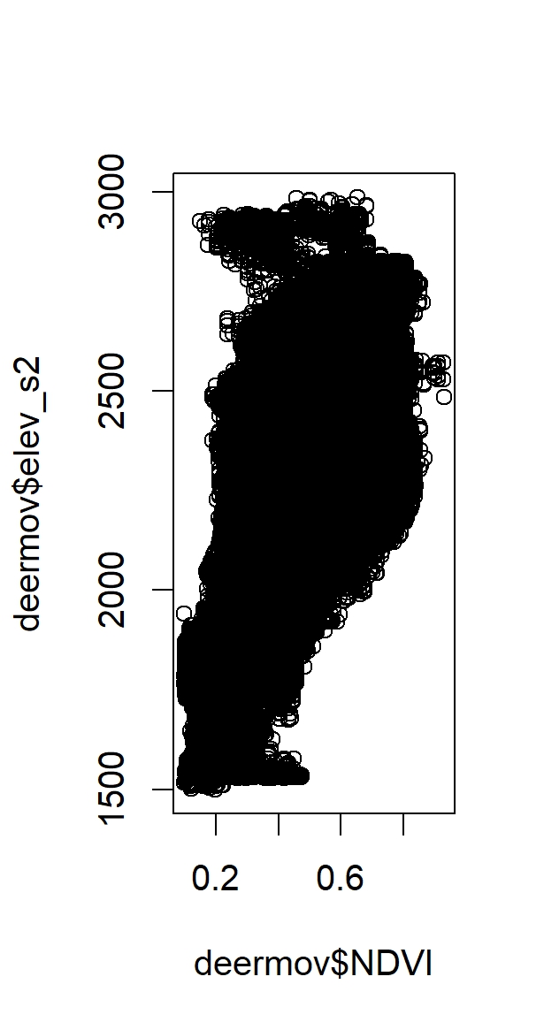

barchart(deermov$season,deermov$dt_rds)

#This barchart was an attempt to break down recorded distance to nearest improved road (dt_rds, y-axis) in reference to biological season category (season, x-axis) however I do not think it worked as I intended it to. Season should have three categories, which is not what is shown below.

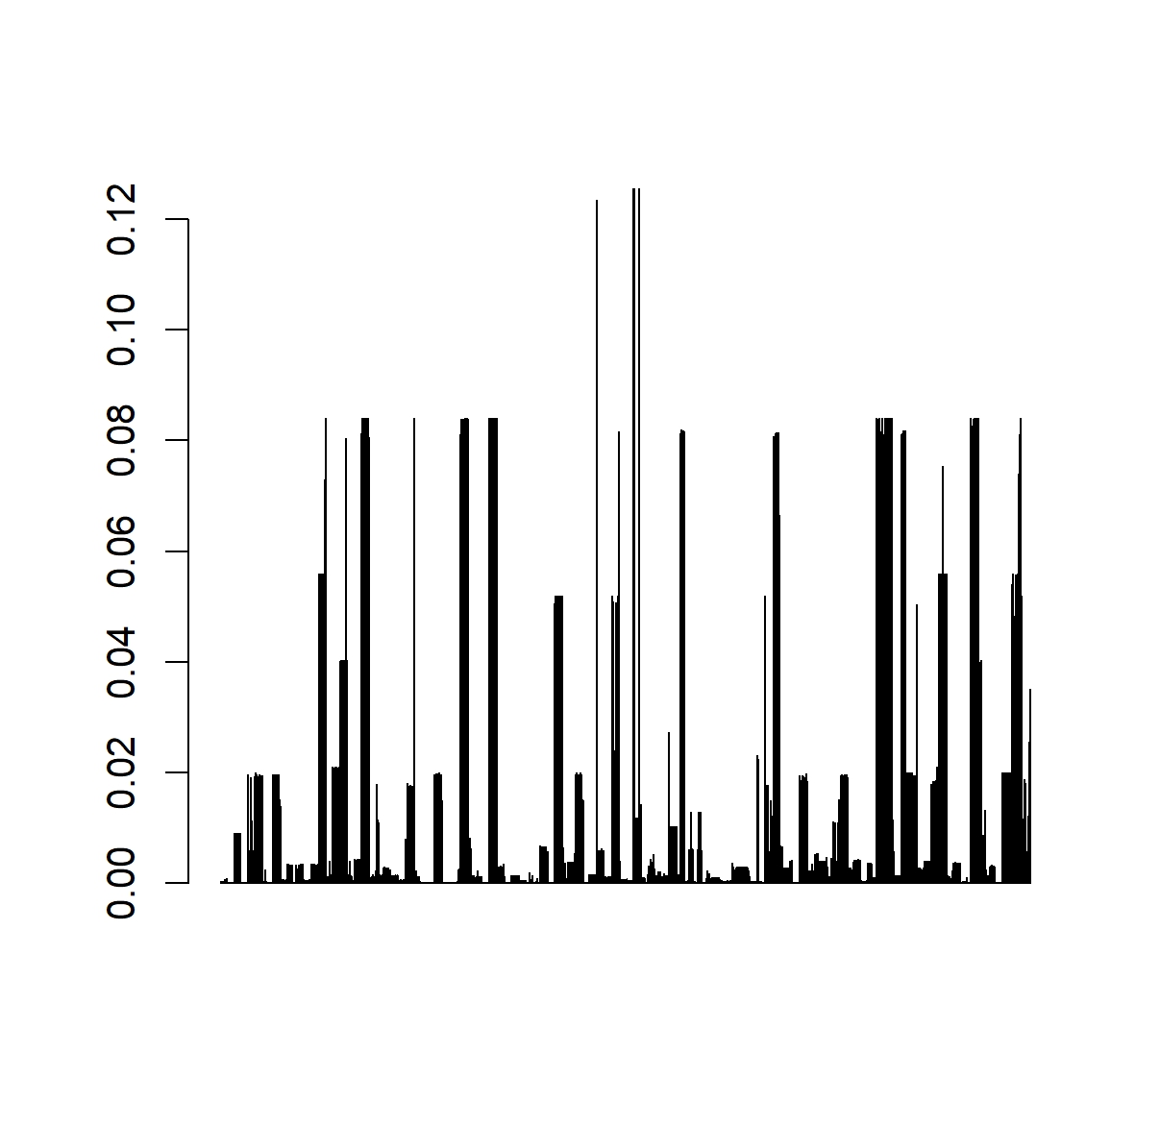

dotchart(deermov$NDVI,deermov$dt_rds)'''

#Would not load command. Quit RStudio multiple times, at this point no command would run properly, even ones that I knew for sure how they should work (ex. class(deermov) and view(deermov))

Copy of complete code:

----

title: "Assignment 1"

author: "Giulietta Schutte"

date: "2025-09-19"

output:

Pdf_document

—

This dataset was used to analyze deer movements to track the impacts (if any) of human and cougar presence on deer behavior. Locations were obtained from female mule deer fitted with a GPS-collar. This does skew the data towards female mule deer behavior and does not give a representation of the species as a whole since only one gender was studied.

I chose this data set because animal habitat use interests me. This data was made public on Dryad. Link to data: [Dryad | Data: Dynamic riskscapes for prey: Disentangling the impact of human and cougar presence on deer behavior using GPS smartphone locations](https://datadryad.org/dataset/doi:10.5061/dryad.51c59zwkg) . Link to published paper using this data: [Ecography - Wiley Online Library](https://nsojournals.onlinelibrary.wiley.com/doi/10.1002/ecog.07626)

The class of the dataset is dataframe. The command str was used to produce a list of variables with their class types. The command summary was used to provide summary statistics for numerical variables. Figure 1 : This plot graph has Normalized Difference Vegetation Index (NDVI) as the x-axis and elevation (meters) as the y-axis. Figure 2: This barchart was an attempt to break down recorded distance to nearest improved road (dt_rds, y-axis) in reference to biological season category (season, x-axis) however I do not think it worked as I intended it to. Season should have three categories, which is not what is shown below. Figure 3: Would not load command. Quit RStudio multiple times, at this point no command would run properly, even ones that I knew for sure how they should work (ex. class(deermov) and view(deermov)).

'''readRDS("C:/Users/schut/Downloads/MD_dataset.RDS")

deermov=readRDS("C:/Users/schut/Downloads/MD_dataset.RDS")

View(deermov)

str(deermov)

summary(deermov)

plot(deermov$NDVI,deermov$elev_s2)

barchart(deermov$season,deermov$dt_rds)

dotchart(deermov$NDVI,deermov$dt_rds)’’’